Lab Report 6

ESE – 3005

EMBEDDED SYSTEMS ARCHITECTURE 2

Submitted to :

Linchan Wang

Submitted by:

Gurvinder Singh(748418)

1.Saving the desired linaro file after downloading.

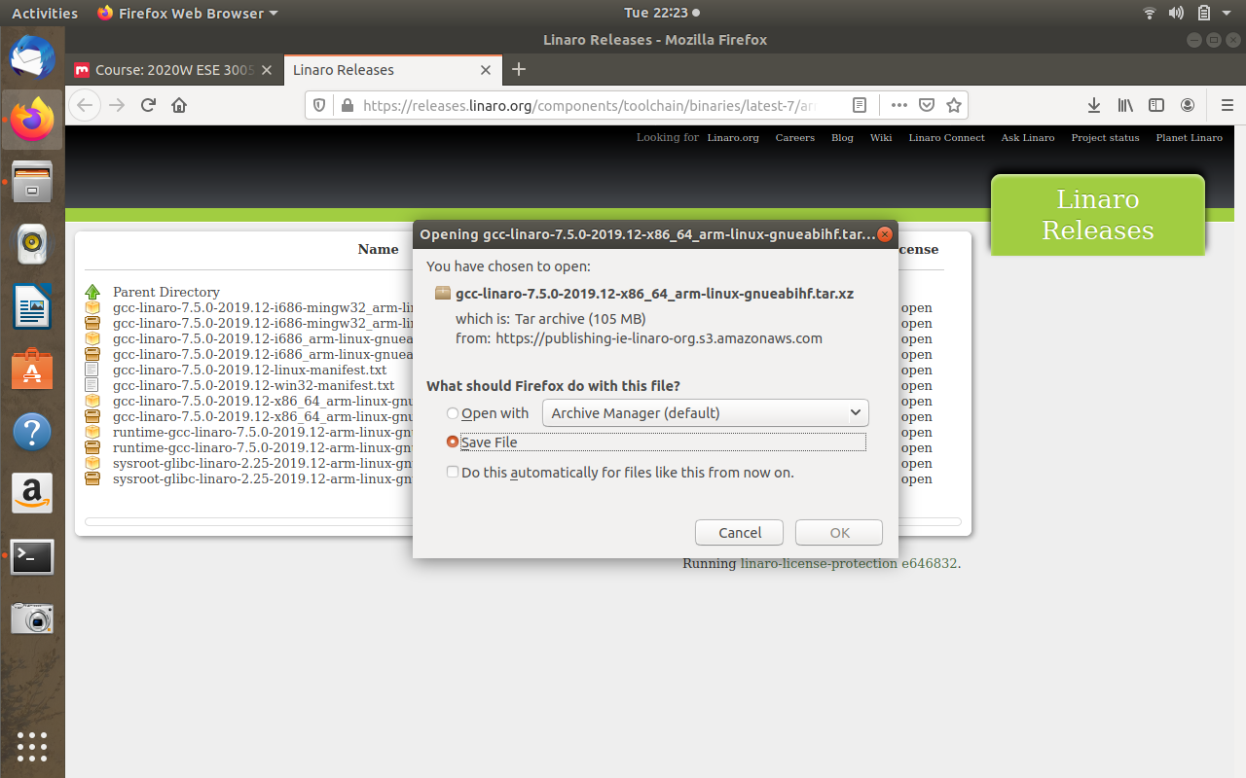

* Steps for Eclipse
* Open Eclipse, after choosing Cross GCC select Hello world ANSI C project and after making some changes in advance settings, define compiler prefix and compiler path according to location of linaro folder.
* Write a Hello World program.

2. Hello World!!!

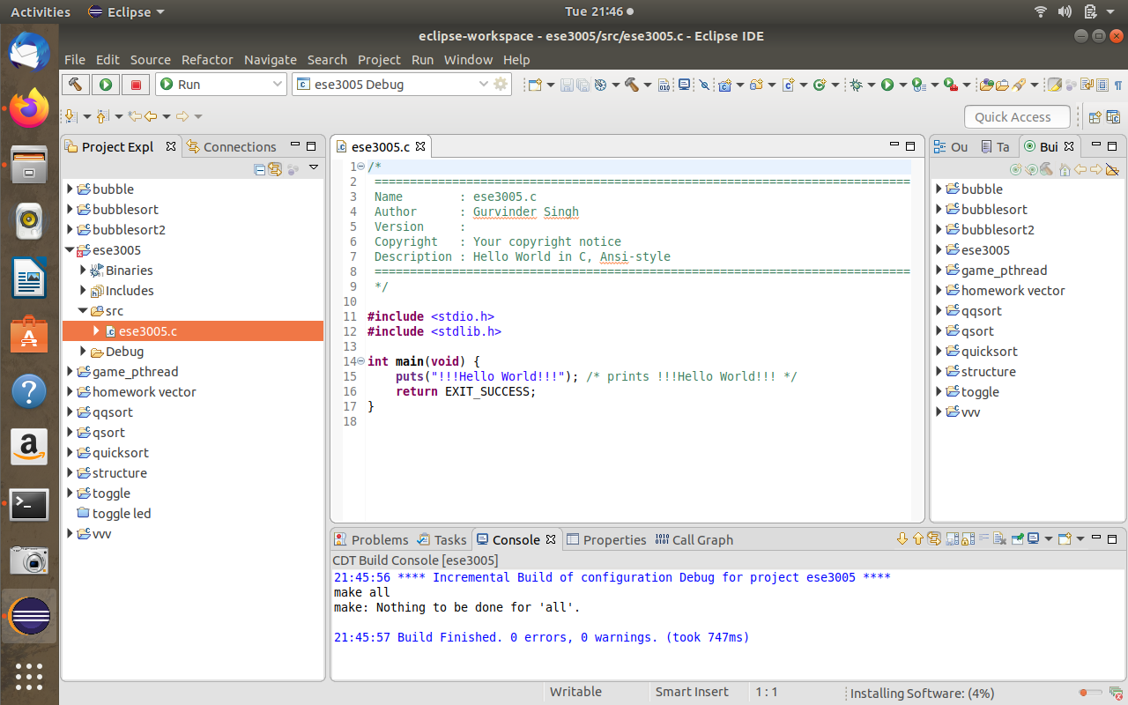

3. After writing the program, connect a beaglebone black and make manual connection to interface beaglebone black with eclipse.

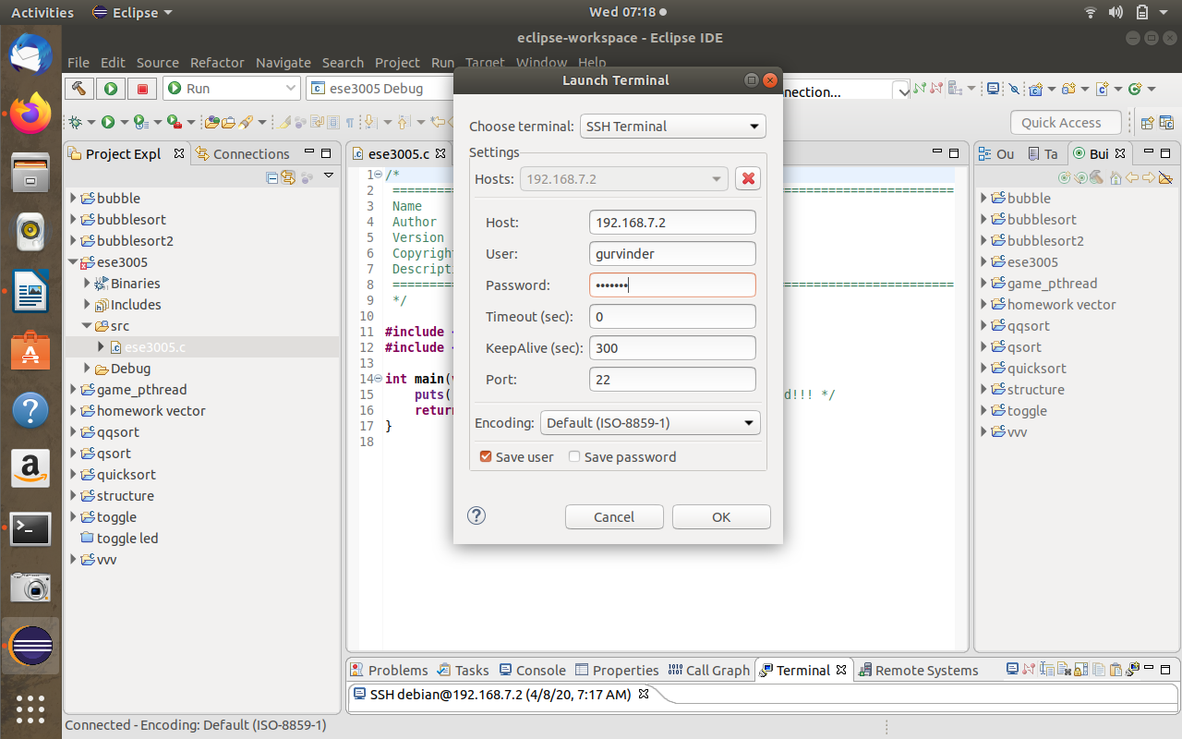

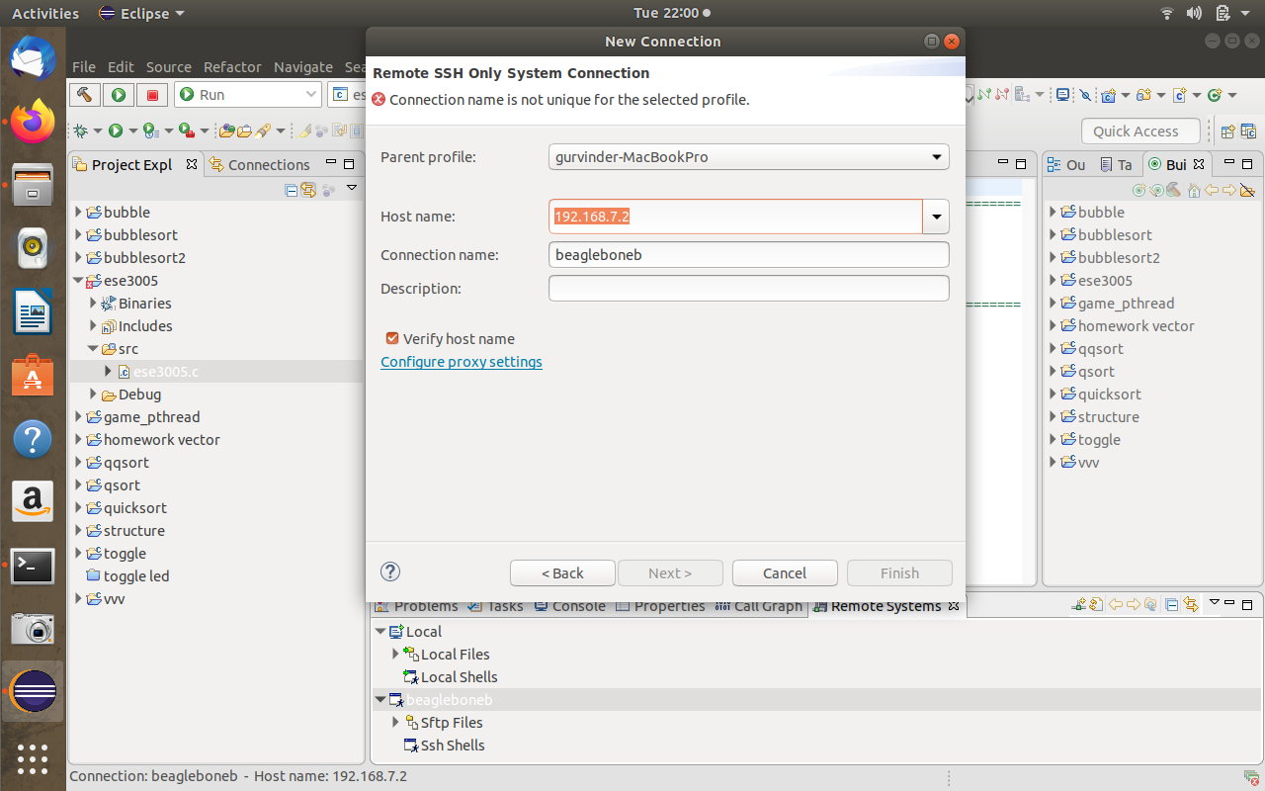

4.Remote System connection with beaglebone black(by setting up username and password)

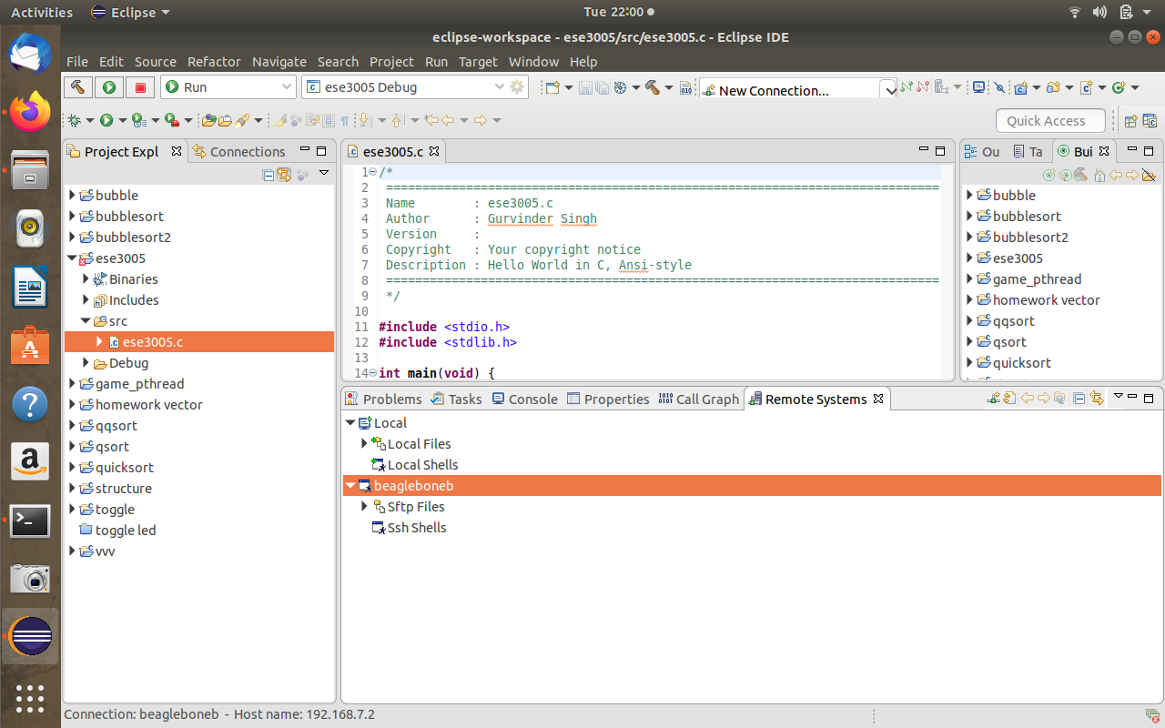

5. Drag and drop the binary files of Hello World!! program in beaglebone.

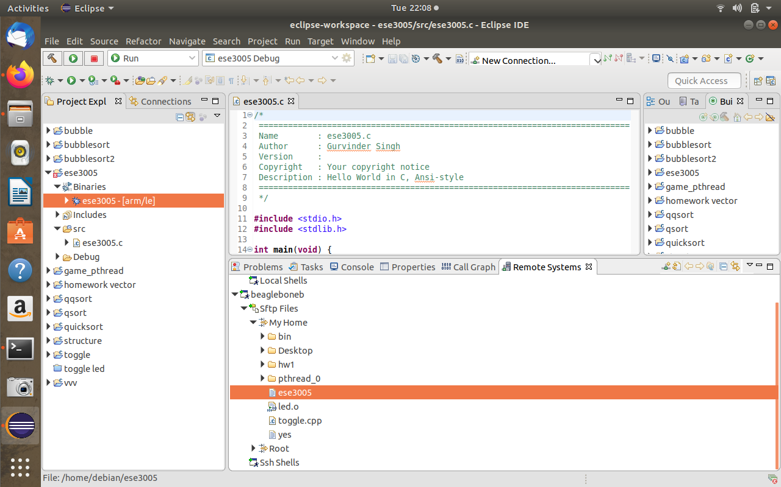

6. Check all the files present on beaglebone and change the preferences 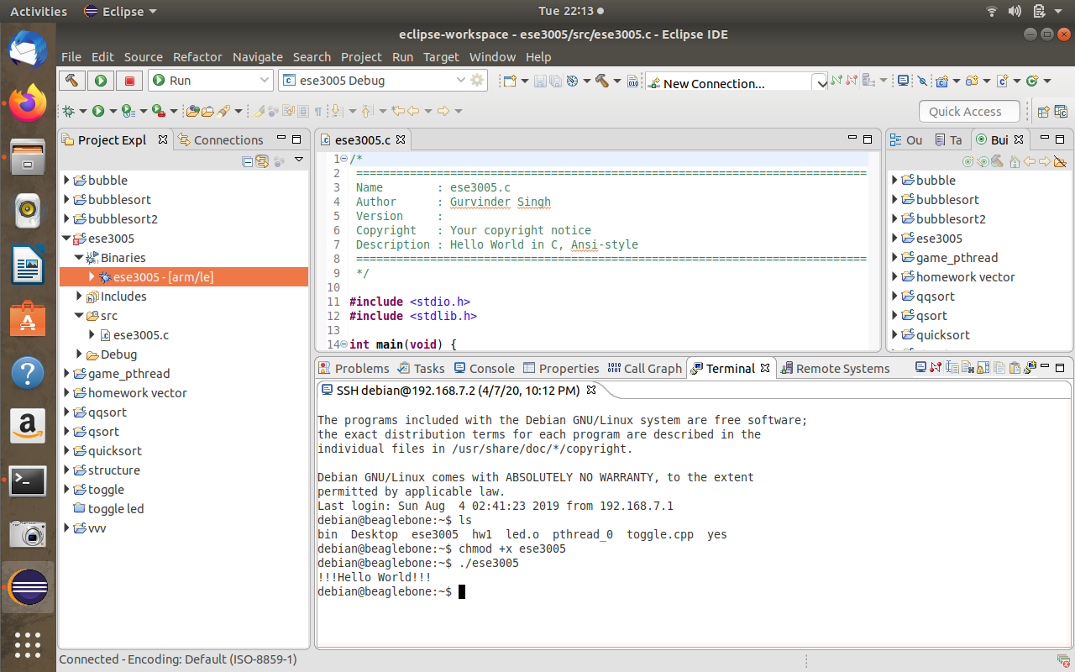of Hello World!! program and execute it...